**1.Write a c++ program to create a class for a bank account with a constructor and a destructor**

**PROGRAM:**

#include <iostream>

#include <string>

class BankAccount {

private:

std::string accountHolderName;

int accountNumber;

double balance;

public:

BankAccount(std::string name, int number, double initialBalance)

: accountHolderName(name), accountNumber(number), balance(initialBalance) {

std::cout << "Account created for " << accountHolderName << " with account number " << accountNumber << " and initial balance $" << balance << std::endl;

}

~BankAccount() {

std::cout << "Account for " << accountHolderName << " with account number " << accountNumber << " is being deleted" << std::endl;

}

void displayAccountDetails() {

std::cout << "Account Holder: " << accountHolderName << std::endl;

std::cout << "Account Number: " << accountNumber << std::endl;

std::cout << "Balance: $" << balance << std::endl;

}

void deposit(double amount) {

balance += amount;

std::cout << "Deposited $" << amount << ". New balance is $" << balance << std::endl;

}

void withdraw(double amount) {

if (amount > balance) {

std::cout << "Insufficient funds!" << std::endl;

} else {

balance -= amount;

std::cout << "Withdrew $" << amount << ". New balance is $" << balance << std::endl;

}

}

};

int main() {

BankAccount account("John Doe", 123456, 1000.0);

account.displayAccountDetails();

account.deposit(500.0);

account.withdraw(200.0);

account.withdraw(1500.0);

return 0;

}

**OUTPUT:**



**2.Write a c++ program to create a class for a car with a constructor and a destructor**

**PROGRAM**

#include <iostream>

#include <string>

class Car {

private:

std::string make;

std::string model;

int year;

public:

Car(std::string make, std::string model, int year) : make(make), model(model), year(year) {

std::cout << "Constructor called for " << make << " " << model << std::endl;

}

~Car() {

std::cout << "Destructor called for " << make << " " << model << std::endl;

}

void display() {

std::cout << "Make: " << make << ", Model: " << model << ", Year: " << year << std::endl;

}

};

int main() {

Car car1("Toyota", "Camry", 2020);

Car car2("Honda", "Accord", 2019);

car1.display();

car2.display();

return 0;

}

**OUTPUT:**

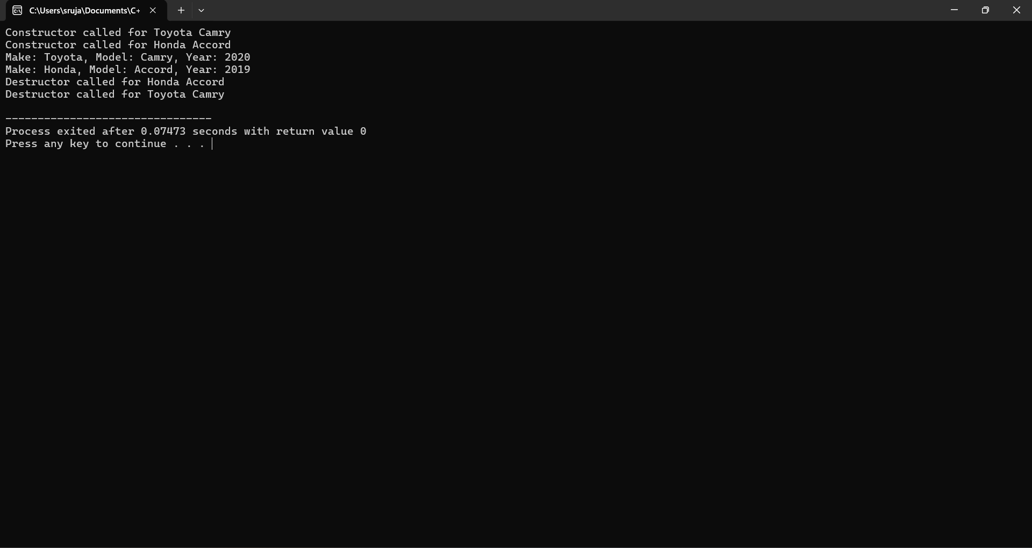

**3.**  **Write a c++ program to create a class for a rectangle with a constructor and a destructor**

**PROGRAM:**

#include <iostream>

class Rectangle {

private:

double length;

double width;

public:

Rectangle(double l, double w) : length(l), width(w) {

std::cout << "Rectangle created with length " << length << " and width " << width << std::endl;

}

~Rectangle() {

std::cout << "Rectangle with length " << length << " and width " << width << " is being deleted" << std::endl;

}

double area() const {

return length * width;

}

double perimeter() const {

return 2 * (length + width);

}

void display() const {

std::cout << "Length: " << length << ", Width: " << width << std::endl;

}

};

int main() {

Rectangle rect(10.0, 5.0);

rect.display();

std::cout << "Area: " << rect.area() << std::endl;

std::cout << "Perimeter: " << rect.perimeter() << std::endl;

return 0;

}

**OUTPUT:**



**4. Write a c++ program to create a class for a book with a constructor and a destructor**

**#include <iostream>**

**#include <string>**

**class Book {**

**private:**

**std::string title;**

**std::string author;**

**public:**

**Book(std::string bookTitle, std::string bookAuthor) : title(bookTitle), author(bookAuthor) {**

**std::cout << "Constructor called for the book: " << title << " by " << author << std::endl;**

**}**

**~Book() {**

**std::cout << "Destructor called for the book: " << title << " by " << author << std::endl;**

**}**

**void display() {**

**std::cout << "Title: " << title << ", Author: " << author << std::endl;**

**}**

**};**

**int main() {**

**Book book1("The Great Gatsby", "F. Scott Fitzgerald");**

**Book book2("To Kill a Mockingbird", "Harper Lee");**

**return 0;**

**}**

**OUTPUT:**

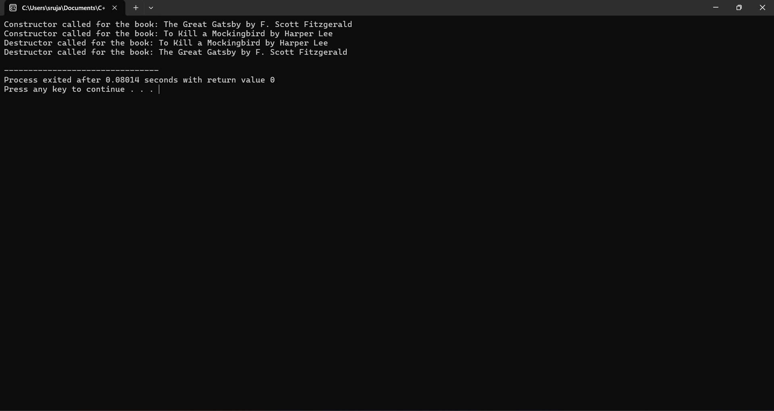

**5. Write a c++ program to create a class for student with a constructor and a destructor**

**PROGRAM:**

#include <iostream>

#include <string>

class Student {

private:

std::string name;

int age;

public:

Student(std::string studentName, int studentAge) : name(studentName), age(studentAge) {

std::cout << "Constructor called for " << name << std::endl;

}

~Student() {

std::cout << "Destructor called for " << name << std::endl;

}

void display() {

std::cout << "Name: " << name << ", Age: " << age << std::endl;

}

};

int main() {

Student student1("John", 20);

Student student2("Alice", 22);

student1.display();

student2.display();

return 0;

}

**OUTPUT:**

